Task 2 – Temperature Converter and Classifier
Write a Python program that asks the user to enter a temperature in Celsius.
The program should: Convert the temperature from Celsius to Fahrenheit.Display the Fahrenheit temperature. Classify the temperature as Cold, Normal, or Hot.
Use these conditions:
Celsius Temperature
Temperature Level
Below 15°C
Cold
15°C–30°C
Normal
Above 30°C
Hot
Display the Fahrenheit value rounded to 2 decimal places. Concepts Covered
input(), float(), arithmetic operators, comparison operators, if-elif-else, and round().
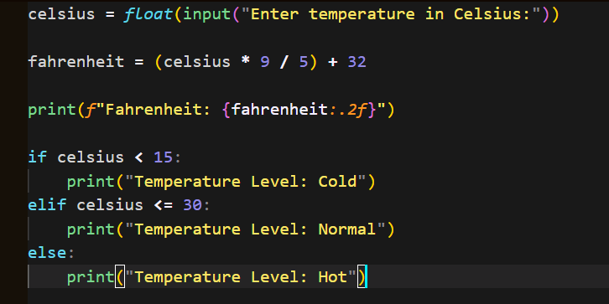
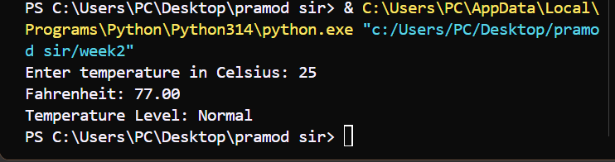

Task 3 – ASCII
Write a Python program that asks the user to enter a string.
The program should encrypt the string by modifying the ASCII value of each character.
For each character:
- Characters at even positions → Add 2 to their ASCII value.
- Characters at odd positions → Subtract 2 from their ASCII value.
Then: Convert each character to its ASCII value using ord().Modify the ASCII value according to its position. Convert the modified ASCII value back to a character using chr().Print the modified ASCII value

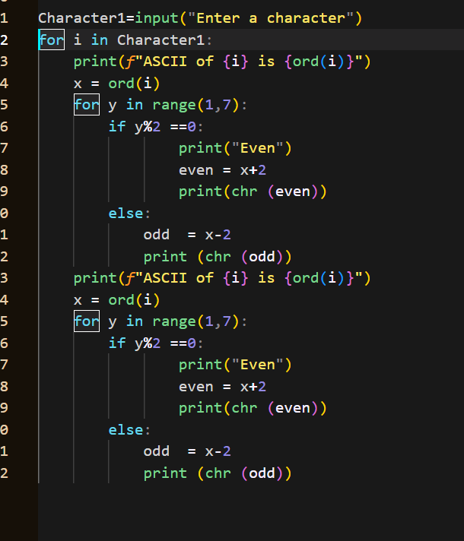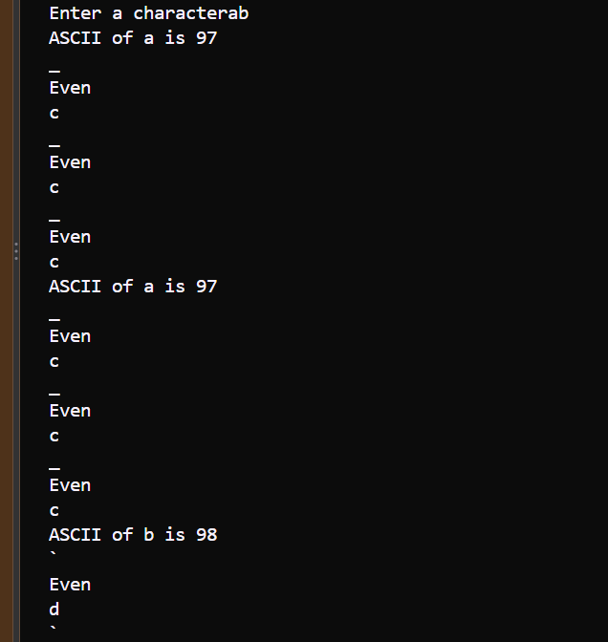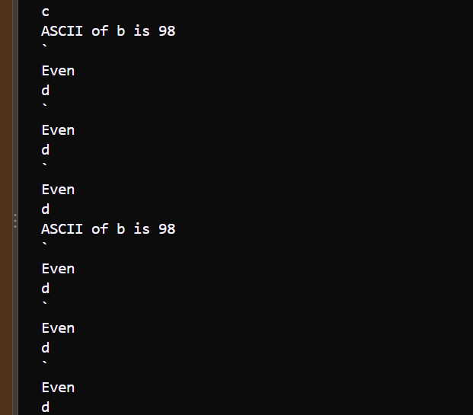

Task 4 – Number System Conversion and Number Analysis
Write a Python program that asks the user to enter a positive integer with at least 3 digits.
The program should first validate the input.
For a valid number, the program should: Display the number in Decimal format. and display the number in Binary format using bin().Convert and display the number in Octal format using oct().Convert and display the number in Hexadecimal format using hex().Display the last digit of the number. Determine whether the number is Even or Odd. Display all results with clear labels. Input Validation
- If the user enters a number with fewer than 3 digits, display:
Please enter a number with at least 3 digits.
- If the user enters 0 or a negative number, display:
Please enter a positive number.

